**CURRENT, RESISTANCE AND ELECTROMOTIVE FORCE**

1. **ELECTRIC CURRENT**

* charges in motion
* the rate of flow of electric charge through a conductor connected between two points of different potentials

$I=\frac{Q}{t}$

where: I = current, Ampere (amp or A)

t = time, s

Q = total charge that flows, coulomb

* Note that for a metallic conductor, charges that flow are electrons

Q= Nq where: N = number of electrons that flow during a time t

q = charge of an electron, |qe| = 1.6x10-19 C

* ***Direction of Current***

CONVENTIONAL FLOW ELECTRON FLOW

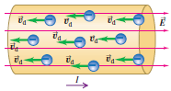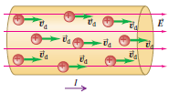

A conventional current is treated as a flow of positive charges (would move from the positive battery terminal and toward the negative terminal).

In a metallic conductor, the moving charges are electrons — but the current still points in the direction positive charges would flow.

The motion of positive charge carriers in one direction has the same effect as the actual motion of negative charge carriers in the opposite direction. So for historical reasons, however, we use the following convention:

*A current arrow is drawn in the direction in which positive charge carriers would move, even if the actual charge carriers are negative and move in the opposite direction.*

* ***Current in Relation to the Drift Velocity of the Charges***

When an electric field $\vec{E}$ is established in a conductor, the charge carriers (assumed positive) acquire a ***drift speed $v_{d}$***  in the direction of $\vec{E}$; the current is related to the drift speed by

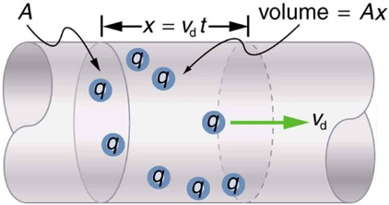

$$I=nqAv_{d}$$

where: A = cross sectional area of conductor (m2)

n = free electron (conduction electron) density or **concentration** of particles

= the number of carriers per unit volume (n = N/V)

* *(nq)* = carrier charge density
* ***Current Density in a Conductor, J***
* It is the current per unit cross-sectional area.
*  A/m2
*  (vector current density)

1. **RESISTIVITY AND RESISTANCE**

* ***Resistivity, $ρ$***
* The quantitative measure of a material’s opposition to the flow of current. It is an intrinsic property of the material (metal element) which depends only (if temperature is constant) on the chemical composition of the material and temperature, not its shape or size.
* *Good conductors have small resistivity; good insulators have large resistivity.*
* **OHM’S LAW:** Was discovered in 1826 by German Physicist Georg Simon Ohm. Ohm’s law states that current density, $J$ is nearly directly proportional to electric field, $\vec{E}$, and the ratio of the magnitudes of $E$ and $J$ is constant.
$$ρ=\frac{E}{J}, Ω.m (definition of resistivity)$$

* The resistivity of a material is the ratio of the magnitudes of electric field and current density.
* ***Resistance, R***
* It is the obstruction or opposition offered by the material (conductor) in the flow of current through it. It is the extrinsic property of the material which depends upon the amount of material present (shape and size).
* Ohm’s law is an assertion that the current $I$ through a device is *always* directly proportional to the potential difference $V$ applied to the device. The ratio of $V$ to $I$ is constant:
$$R=\frac{V}{I}, Ω (definition of resistance)$$

* The resistance of a cylindrical conductor is related to its resistivity, length , and cross-sectional area 
$$R=ρ\frac{L}{A}$$

* *Temperature Dependence of Resistivity*
* The resistivity increases when the temperature increases except for some materials like carbon

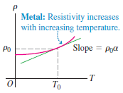

**Metal:** Resistivity increases

with increasing temperature.

Slope = m = $\frac{Δρ}{ΔT}= \frac{ρ_{1}-ρ_{0}}{T_{1}- T_{0}}$

Where: ρ0 and ρ1 = resistivity at temperature T0 and T1 respectively

$$ρ_{1}=ρ_{0}\left[1+ \frac{m}{ρ_{0}}\left(T_{1}-T_{0}\right)\right]$$

Where:

$\frac{m}{ρ_{0}}$ = $α_{0}$ = temperature coefficient of the material

$ρ_{1}=ρ_{0}\left[1+ α_{0}\left(T_{1}-T_{0}\right)\right]$

Since $R∝ρ$, then:

$$R_{1}=R_{0}\left[1+ α_{0}\left(T_{1}-T_{0}\right)\right]$$

1. **ELECTROMOTIVE FORCE, emf or ℰ**

* Not a force but an energy-per-unit-charge quantity that is imparted by an energy source.
* It is the influence that makes current flow from lower to higher potential.
* Sources may be batteries, electric generators, or any kind of cells.

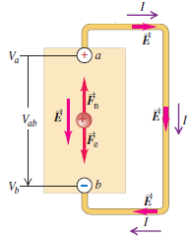

ℰ

*R*

* If *source is ideal: $V_{ab}=E=IR$*
* In reality, $V_{ab}≠E$ because of the internal resistance $r$ of the source.

*A Source on Open Circuit & in a Closed or Complete Circuit*

1. 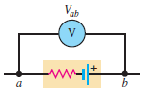**Open circuit: no current flows**

$Terminal Voltage: V= E$

*r ℰ*

1. **Closed circuit:**
2. 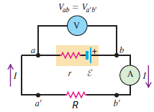**Current flows out from the source (Discharging Source)**

$Terminal voltage: V= E-Ir$

1. **Current flows into the source (Charging Source)**

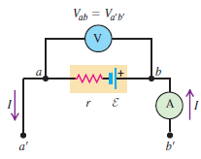

$Terminal volatge: V= E+Ir$

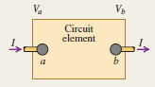**ELECTRICAL POWER AND ENERGY IN CIRCUITS**

* **Power, *P*:** time rate of energy transfer
  + In general:
$$P=V_{ab}I$$

* For resistors:
 $$P={V_{ab}I=I}^{2}R=\frac{{V_{ab}}^{2}}{R} Watt, kW$$

 + For batteries:
* *Power Output of a Source* (Discharging Source)

$$P=V_{ab}I=\left(E-Ir\right)I=EI-I^{2}r$$

Where: = rate of conversion of battery energy to electric energy

= energy *dissipated* in the internal resistance

= net electrical power output of the source or the rate at which the source delivers electrical energy to the remainder of the circuit

* *Power Input to a Source* (Charging Source)
$$P=V_{ab}I=\left(E+Ir\right)I=EI+I^{2}r$$

* **Energy Transfer:**

$$Energy=Pt=VIt= I^{2}Rt=\frac{V^{2}t}{R} Watt.s, kWh, J$$

SAMPLE PROBLEMS:

1. A steady current of 2.5 A exists in a wire for 4.0 min. (a) How much total charge passed by a given point in the circuit during those 4.0 min? (b) How many electrons would this be?
2. A 200-km-long high-voltage transmission line 2 cm in diameter carries a steady current of 1000 A. If the conductor is copper with a free charge density of 8.50 x 1028 electrons per cubic meter, how many years does it take one electron to travel the full length of the cable?
3. An 18-gauge copper wire (ρ = 1.72x10-8.m) has a diameter of 1.02 mm and a cross-sectional area of 8.20x10-7m2. It carries a current of 1.67 A. Find (a) the electric-field magnitude in the wire; (b) the potential difference between two points in the wire 50m apart; (c) the resistance of a 50m length of this wire.
4. A certain lightbulb has a tungsten filament with a resistance of 19 V when at 20°C and 140 V when hot. Assume the resistivity of tungsten varies linearly with temperature even over the large temperature range involved here. Find the temperature of the hot filament. (αTungsten = 4.5 x 10-3/OC)
5. When an external resistance of 10 ohms is connected to a source, a current of 0.5A flows, when the resistance is changed to 20 ohms, the current becomes 0.3 amperes. What are the open circuit emf and the internal resistance of the source?
6. A battery has an emf of 15.0 V. The terminal voltage of the battery is 11.6 V when it is delivering 20.0 W of power to an external load resistor R. (a) What is the value of R? (b) What is the internal resistance of the battery?